2018 Water Quality Report for Haring Charter Township
This report covers the drinking water quality for Haring Charter Township for the 2018 calendar year. This information is a snapshot of the quality of the water that we provided to you in 2018. Included are details about where your water comes from, what it contains, and how it compares to United States Environmental Protection Agency (U.S. EPA) and state standards.
Your water comes from 2 (two) groundwater wells, each over 260 feet deep. The State performed an assessment of our source water to determine the susceptibility or the relative potential of contamination. The susceptibility rating is on a seven-tiered scale from "very-low" to "very-high" based on geologic sensitivity, well construction, water chemistry and contamination sources. Our source water has a moderate susceptibility to the potential of contamination. A copy of this assessment report is available at the Haring Charter Township Hall located at 515 Bell Ave. Cadillac, MI 49601.
If you would like to know more about the report, please contact Bob Polanic by phone at (616)204-1866 or (231)577-8793 or by email at bpolanic@iaiwater.com.

Contaminants and their presence in water: Drinking water, including bottled water, may reasonably be expected to contain at least small amounts of some contaminants. The presence of contaminants does not necessarily indicate that water poses a health risk. More information about contaminants and potential health effects can be obtained by calling the U.S. EPA’s Safe Drinking Water Hotline (800-426-4791).
Vulnerability of sub-populations: Some people may be more vulnerable to contaminants in drinking water than the general population. Immuno-compromised persons such as persons with cancer undergoing chemotherapy, persons who have undergone organ transplants, people with HIV/AIDS or other immune systems disorders, some elderly, and infants can be particularly at risk from infections. These people should seek advice about drinking water from their health care providers. U.S. EPA/Center for Disease Control guidelines on appropriate means to lessen the risk of infection by Cryptosporidium and other microbial contaminants are available from the Safe Drinking Water Hotline (800-426-4791).
Sources of drinking water: The sources of drinking water (both tap water and bottled water) include rivers, lakes, streams, ponds, reservoirs, springs, and wells. Our water comes from wells. As water travels over the surface of the land or through the ground, it dissolves naturally-occurring minerals and, in some cases, radioactive material, and can pick up substances resulting from the presence of animals or from human activity.
Contaminants that may be present in source water include:
- Microbial contaminants, such as viruses and bacteria, which may come from sewage treatment plants, septic systems, agricultural livestock operations and wildlife.
- Inorganic contaminants, such as salts and metals, which can be naturally-occurring or result from urban stormwater runoff, industrial or domestic wastewater discharges, oil and gas production, mining or farming.
- Pesticides and herbicides, which may come from a variety of sources such as agriculture and residential uses.
- Radioactive contaminants, which can be naturally occurring or be the result of oil and gas production and mining activities.
- Organic chemical contaminants, including synthetic and volatile organic chemicals, which are by-products of industrial processes and petroleum production, and can also come from gas stations, urban stormwater runoff, and septic systems.
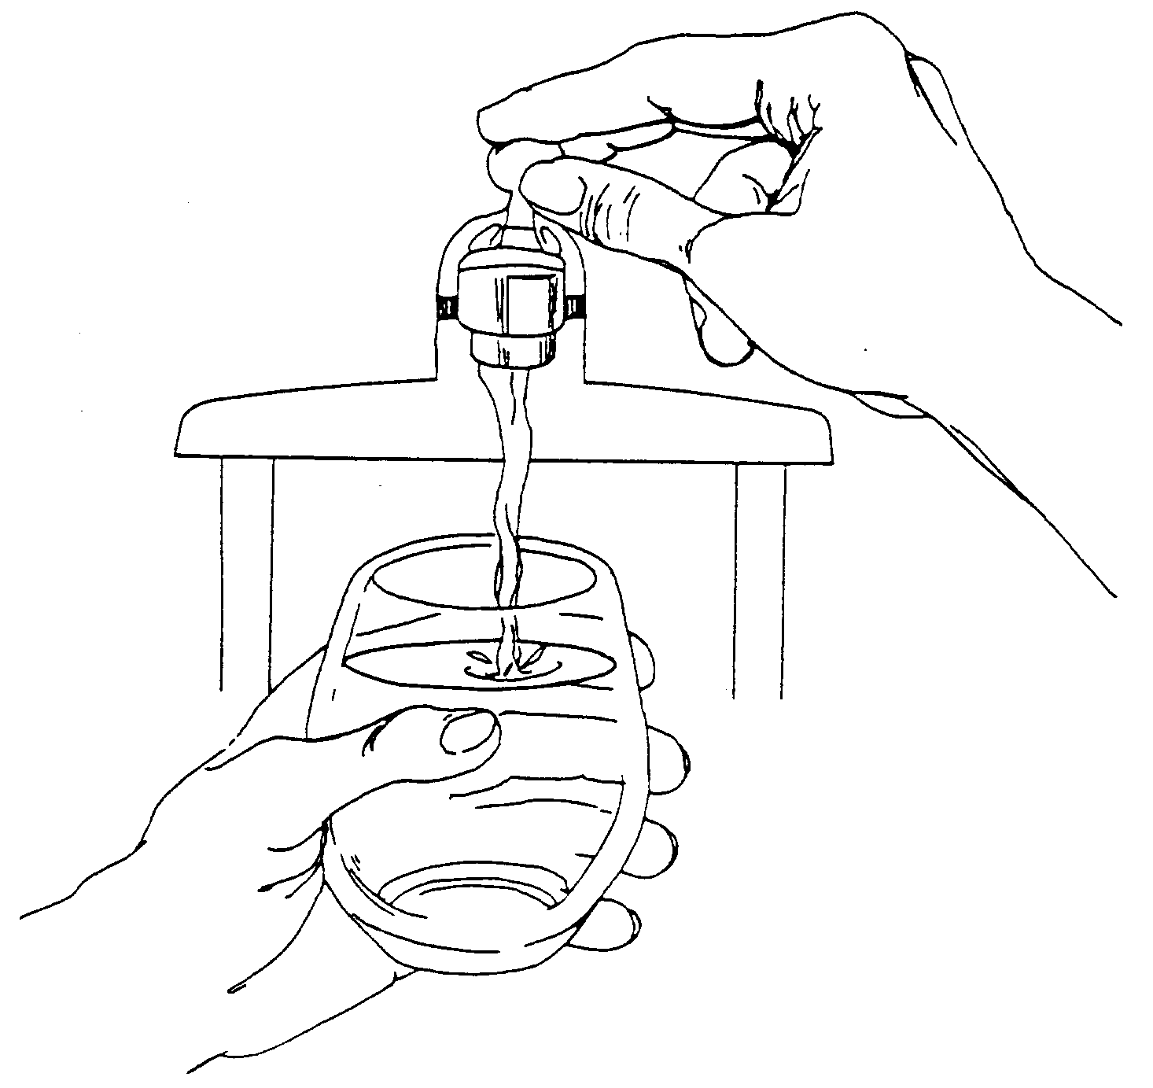
In order to ensure that tap water is safe to drink, the U.S. EPA prescribes regulations that limit the levels of certain contaminants in water provided by public water systems. Federal Food and Drug Administration regulations establish limits for contaminants in bottled water which provide the same protection for public health.

Water Quality Data
The table below lists all the drinking water contaminants that we detected during the 2018 calendar year. The presence of these contaminants in the water does not necessarily indicate that the water poses a health risk. Unless otherwise noted, the data presented in this table is from testing done January 1 through December 31, 2018. The State allows us to monitor for certain contaminants less than once per year because the concentrations of these contaminants are not expected to vary significantly from year to year. All the data is representative of the water quality, but some are more than one year old.

Terms and abbreviations used below:
- Maximum Contaminant Level Goal (MCLG): The level of a contaminant in drinking water below which there is no known or expected risk to health. MCLGs allow for a margin of safety.
- Maximum Contaminant Level (MCL): The highest level of a contaminant that is allowed in drinking water. MCLs are set as close to the MCLGs as feasible using the best available treatment technology.
- Maximum Residual Disinfectant Level (MRDL): The highest level of a disinfectant allowed in drinking water. There is convincing evidence that addition of a disinfectant is necessary for control of microbial contaminants.
- Maximum Residual Disinfectant Level Goal (MRDLG): The level of a drinking water disinfectant below which there is no known or expected risk to health. MRDLGs do not reflect the benefits of the use of disinfectants to control microbial contaminants.
- Treatment Technique (TT): A required process intended to reduce the level of a contaminant in drinking water.
- N/A: Not applicable
- ND: not detectable at testing limit
- ppb: parts per billion or micrograms per liter
- ppm: parts per million or milligrams per liter
- Action Level (AL): The concentration of a contaminant which, if exceeded, triggers treatment or other requirements that a water system must follow.
During the monitoring period from 11/1/18 to 11/30/18 we did not take the required number of routine samples for TTHM Total Trihalomethanes and HAA5 Haloacetic Acids. This violation did not pose a threat to the quality of the drinking water. The samples were taken at the wrong locations which made the results unreportable. Samples were taken at the correct locations but not during the correct monitoring period which made those samples also unreportable. All samples showed a decrease in levels from the previous year. Sampling will be performed during the proper time frame and at the proper locations immediately this year to insure ample time for resampling if any issues arise.

Information about lead: If present, elevated levels of lead can cause serious health problems, especially for pregnant women and young children. Lead in drinking water is primarily from materials and components associated with service lines and home plumbing. Haring Charter Township is responsible for providing high quality drinking water but cannot control the variety of materials used in plumbing components. When your water has been sitting for several hours, you can minimize the potential for lead exposure by flushing your tap for 30 seconds to 2 minutes before using water for drinking or cooking. If you are concerned about lead in your water, you may wish to have your water tested. Information on lead in drinking water, testing methods, and steps you can take to minimize exposure is available from the Safe Drinking Water Hotline or at http://www.epa.gov/safewater/lead.
Monitoring and Reporting to the Department of Environmental Quality (DEQ) Requirements: The State of Michigan and the U.S. EPA require us to test our water on a regular basis to ensure its safety.
We will update this report annually and will keep you informed of any problems that may occur throughout the year, as they happen. Copies are available at Haring Charter Township Hall located at 515 Bell Ave. Cadillac, MI 49601. This report will not be sent to you.
We invite public participation in decisions that affect drinking water quality. Haring Charter Township Board meetings are held at the Township Hal (515 Bell Ave. Cadillac, MI 49601) at 6:00 PM on the second Monday of each month. For more information about your water, or the contents of this report, contact Bob Polanic by phone at (616)204-1866 or (231)577-8793 or email at bpolanic@iaiwater.com. For more information about safe drinking water, visit the U.S. Environmental Protection Agency at www.epa.gov/safewater/lead.

Regulated Contaminant | MCL, TT, or MRDL | MCLG or MRDLG | Level Detected | Range | Year Sampled | Violation Yes/No | Typical Source of Contaminant
Barium (ppm) | 2 | 2 | 0.02 | N/A | 2015 | No | Discharge of drilling wastes; Discharge of metal refineries; Erosion of natural deposits
Nitrate (ppm) | 10 | 10 | ND | N/A | 2018 | No | Runoff from fertilizer use; Leaching from septic tanks, sewage; Erosion of natural deposits
Fluoride (ppm) | 4 | 4 | ND | N/A | 2018 | No | Erosion of natural deposits; Water additive which promotes strong teeth; Discharge from fertilizer and aluminum factories
Sodium (ppm) | N/A | N/A | 13 | 11-13 | 2018 | No | Erosion of natural deposits
TTHM Total Trihalomethanes (ppb) | 80 | N/A | 77 | N/A | 2017 | No | Byproduct of drinking water disinfection
HAA5 Haloacetic Acids (ppb) | 60 | N/A | 34 | 0-34 | 2017 | No | Byproduct of drinking water disinfection
Chlorine (ppm) | 4 | 4 | RAA 0.1 | 0.1-0.57 | 2018 | No | Water additive used to control microbes
Alpha emitters (pCi/L) | 15 | 0 | 0.54 | 0.45-0.54 | 2013 | No | Erosion of natural deposits
Combined radium (pCi/L) | 5 | 0 | 0.46 | 0.14-0.46 | 2016 | No | Erosion of natural deposits
Total Coliform (total number or % of positive samples/month) | TT | N/A | 0 | N/A | 2018 | No | Naturally present in the environment
E. coli in the distribution system (positive samples) | See E. coli note | 0 | 0 | N/A | 2018 | No | Human and animal fecal waste
Inorganic Contaminant Subject to Action Levels (AL) | Action Level | MCLG | Your Water | Range of Results | Year Sampled | Number of Samples Above AL | Typical Source of Contaminant
Lead (ppb) | 15 | 0 | 90th %  Jan-Jun: 4  Jul-Dec: 4 | ND-5.7 | 2018 | 0 | Lead service lines, corrosion of household plumbing including fittings and fixtures; Erosion of natural deposits
Copper (ppm) | 1.3 | 1.3 | 90th %  Jan-Jun: 0.57  Jul-Dec: 0.16 | ND-1.82 | 2018 | Jan-Jun: 1  Jul-Dec: 0 | Corrosion of household plumbing systems; Erosion of natural deposits

Instructions to Water Supplier
**Note: The CCR should contain the most recent data in the last five years.
- Under "Level Detected" and “Range”:
  - enter the highest test result from the lab UNLESS a contaminant’s compliance is determined based on a running annual average. Then, list the highest running annual average.
  - range such as "12-48" (if you sample more than once or from multiple locations).
  - enter the test result from the lab report for sodium, even if it was not detected.
- Under "Year Sampled," enter the year sampled (if earlier than the year covered by the report).
- Under "Violation Yes / No," enter "Yes" to indicate a violation of MCLs, MRDLs, or treatment techniques. Below the table, include a description of the violation, the mandatory health effects language (from Table 1 of R 325.10405), and actions taken to address the violation.
- If arsenic was detected above 5 ppb but at or below 10 ppb include the following:
While your drinking water meets the U.S. EPA standard for arsenic, it does contain low levels of arsenic. The U.S EPA standard balances the current understanding of arsenic's possible health effects against the costs of removing arsenic from drinking water. The U.S. EPA continues to research the health effects of low levels of arsenic, which is a mineral known to cause cancer in humans at high concentrations and is linked to other health effects such as skin damage and circulatory problems.
- If nitrate was detected above 5 ppm but below 10 ppm include the following:
Nitrate in drinking water at levels above 10 ppm is a health risk for infants of less than six months of age. High nitrate levels in drinking water can cause blue baby syndrome. Nitrate levels may rise quickly for short periods of time because of rainfall or agricultural activity. If you are caring for an infant, you should ask for advice from your health care provider.
- For supplies with lead service lines (or service lines of unknown material), include the number of lead service lines, the number of service lines of unknown material, and the total number of service lines in the supply.
- Although it is not required to list the number of total coliform-positive samples, the number of
E. coli-positive samples from the distribution system or raw wells must be included in the table.
- If monitoring requirements were not met, explain the violation such as:
During the monitoring period from _____ to _____ we did not take the required number of routine samples for [enter contaminant name]. This violation did not pose a threat to the quality of the drinking water. [FURTHER EXPLAIN WHAT HAPPENED, ACTIONS TAKEN TO REMEDY THE SITUATION, POTENTIAL HEALTH EFFECTS, AND STEPS TAKEN TO PREVENT ANOTHER VIOLATION.]
- If a Level 1 Assessment or a Level 2 Assessment was required, include the following, as appropriate:
  - During the past year we were required to conduct [INSERT NUMBER OF LEVEL 1 ASSESSMENTS] Level 1 Assessment(s). [INSERT NUMBER OF LEVEL 1 ASSESSMENTS] Level 1 Assessment(s) were completed. In addition, we were required to take [INSERT NUMBER OF CORRECTIVE ACTIONS] corrective actions and we completed [INSERT NUMBER OF CORRECTIVE ACTIONS] of these actions.
  - During the past year [INSERT NUMBER OF LEVEL 2 ASSESSMENTS] Level 2 Assessments were required to be completed for our water supply. [INSERT NUMBER OF LEVEL 2 ASSESSMENTS] Level 2 Assessments were completed. In addition, we were required to take [INSERT NUMBER OF CORRECTIVE ACTIONS] corrective actions and we completed [INSERT NUMBER OF CORRECTIVE ACTIONS] of these actions.
- If a Level 1 Assessment or a Level 2 Assessment was required but not completed, or the identified sanitary defects were not corrected, include the following, as appropriate:
During the past year we failed to conduct all the required assessment(s).
During the past year we failed to correct all identified defects that were found during the assessment.
- If a Level 1 Assessment or a Level 2 Assessment was required that was not due to an E. coli MCL violation, include the following:
Coliforms are bacteria that are naturally present in the environment and are used as an indicator that other, potentially harmful, waterborne pathogens may be present or that a potential pathway exists through which contamination may enter the drinking water distribution system. We found coliforms, indicating the need to look for potential problems in water treatment or distribution. When this occurs, we are required to conduct assessment(s) to identify problems and to correct the problems that were found during these assessments.
- If a Level 2 Assessment was required due to a E. coli MCL violation, include the following:
E. coli are bacteria whose presence indicates that the water may be contaminated with human or animal wastes. Human pathogens in these wastes can cause short-term effects such as diarrhea, cramps, nausea, headaches, or other symptoms. They may pose a greater health risk for infants, young children, the elderly, and people with severely compromised immune systems. We found E. coli bacteria, indicating the need to look for potential problems in water treatment or distribution. When this occurs, we are required to conduct assessment(s) to identify problems and to correct the problems that were found during these assessments.
We were required to complete a Level 2 Assessment because we found E. coli in our water system. In addition, we were required to take [INSERT NUMBER OF CORRECTIVE ACTIONS] corrective actions and we completed [INSERT NUMBER OF CORRECTIVE ACTIONS] of these actions.
- If E. coli was detected and the E. coli MCL was violated, include the following, as appropriate:
  - We had an E. coli-positive repeat sample following a total coliform-positive routine sample.
  - We had a total coliform-positive repeat sample following an E. coli-positive routine sample.
  - We failed to take all required repeat samples following an E. coli-positive routine sample.
  - We failed to test for E. coli when a repeat sample tests positive for total coliform.
- If the groundwater supply has any uncorrected significant deficiency, as designated by the DEQ, or fecal indicator positive source sample result during the year, include the following elements:
  - Nature of the significant deficiency or source of the fecal contamination, if known, and the date(s).
  - Whether the fecal contamination has been addressed and date addressed.
  - For unaddressed significant deficiencies and unaddressed fecal contamination, the approved plan and schedule for correction, including interim measures, and progress to date.
  - The potential health effects of the fecal indicator positive source sample.

Sodium is not a regulated contaminant.
The chlorine “Level Detected” was calculated using a running annual average.
E. coli MCL violation occurs if: (1) routine and repeat samples are total coliform-positive and either is E. coli-positive, or (2) the supply fails to take all required repeat samples following E. coli-positive routine sample, or (3) the supply fails to analyze total coliform-positive repeat sample for E. coli.
Ninety (90) percent of the samples collected were at or below the level reported for our water. Copper is an essential nutrient, but some people who drink water containing copper in excess of the action level over a relatively short amount of time could experience gastrointestinal distress. Some people who drink water containing copper in excess of the action level over many years could suffer liver or kidney damage. People with Wilson’s Disease should consult their personal doctor.

